

General Information

for

THE 25th INTERNATIONAL
TOWING TANK CONFERENCE

Fukuoka, Japan
September 14 20, 2008


Hosted by
The Japan Society of Naval Architects and Ocean Engineers

Technical Programme

Sunday, September 14
14:00 – 16:00 | Advisory Council Meeting and  Registration
16:00 – 16:30 | Coffee Break
16:30 – 17:30 | Executive Committee Meeting  and Registration
18:00 – 20:00 | Reception  at Fukuoka Sunpalace Hotel

Monday, September 15
08:00 – 09:00 | Registration
09:00 – 09:30 | Welcome and Opening
09:30 – 10:00 | Executive Committee Report
10:00 – 10:30 | Coffee Break
10:30 – 12:00 | Resistance Committee
12:00 – 13:15 | Lunch
13:15 – 14:30 | Powering Performance
14:30 – 15:00 | Coffee Break
15:00 – 16:15 | Uncertainty Analysis
16:15 – 16:45 | Coffee Break
16:45 – 18:00 | Quality Systems Group

Tuesday, September 16
09:00 – 10:15 | Cavitation
10:15 – 10:35 | Coffee Break
10:35 – 12:05 | Propulsion Committee
12:05 – 12:30 | Taking Photograph of Participants
12:30 – 13:40 | Lunch
13:40 – 14:55 | Wakefield
14:55 – 15:15 | Coffee Break
15:15 – 16:30 | Azimuthing Podded Propulsion
16:30 – 18:00 | Group Discussions 1 (GD1)  GD1- Impact of CFD on Ship  Hydrodynamics
 | * Technical Session on Ice includes discussions on “Impact of increasing Arctic and Antarctic marine operations on the ITTC”
Wednesday, September 17
09:00 – 10:15 | Stability in Waves
10:15 – 10:45 | Coffee Break
10:45 – 12:15 | Manoeuvring Committee
12:15 – 13:30 | Lunch
13:30 – 15:00 | Seakeeping Committee
15:00 – 15:30 | Coffee Break
15:30 – 17:00 | GD2- Image-based Measurements  around Ship Hulls
17:00 – 18:00 | Advisory Council Meeting

Thursday, September 18
09:00 – 11:00 | Executive Committee Meeting
11:00 – 12:30 | Lunch
12:30 – 18:00 | Conference Tour

Friday, September 19
09:00 – 10:15 | Vortex Induced Vibration
10:15 – 10:45 | Coffee Break
10:45 – 12:15 | Ocean Engineering Committee
12:15 – 13:30 | Lunch
13:30 – 14:45 | Ice*
14:45 – 15:15 | Coffee Break
15:15 – 16:45 | GD3- Global Warming and Impact on  ITTC Activities
18:30 – 21:00 | Banquet
Saturday, September 20
09:00 – 10:15 | Plenary Session and Closing
10:15 – 10:45 | Coffee Break
10:45 – 12:15 | Executive Committee and New  Committee Meeting
12:15 – 14:00 | Lunch
14:00 – | Post Conference Tours

Discussion during the 25th ITTC

The technical session of the 25th ITTC will be organized in the traditional manner. There will be a presentation of a report by each Technical Committee. This presentation should be limited to 45 minutes duration for the General Committees and 30 minutes duration for the Specialist Committees and Group, leaving the last 45 minutes of the session for open discussions. The discussion should concentrate on the opinions, conclusions and recommendations expressed by the Committee.

Discussion within 1,000 words of length must be submitted in writing in order to be published in Volume III of the Proceedings. Oral (non-written) discussions will be allowed by the session chairman to the extent that time allows, but they will not be published unless they are later sent in writing to the Conference Secretariat.

If you wish to make your own discussion available in writing to all participants during the Conference, it can be done in two ways:
- mail your written discussion to the Executive Committee Secretary sufficiently early to be received by the 14th of August 2008, the Secretariat will prepare the necessary number of copies and distribute them at the Conference;
- prepare and bring 200 copies of your discussion and hand them over to the Secretariat upon arrival in Fukuoka.

It is essential that the names of the Technical Committee and of the discusser are shown at the top of each page of the written discussion.

In order to assist the Secretariat in preparing the Volume III of the proceedings, we would also appreciate if you could provide us with your written discussion as a Word document on a CD or USB flash memory drive or by e-mail attached file, compatible with Windows 2000/XP.

Group Discussions
Beside the traditional technical sessions, a programme of group discussions on specific topics has been established to be held during the 25th ITTC. Three group discussions will be held in the afternoons on Tuesday, September 16 (GD1), on Wednesday, September 17 (GD2) and on Friday, September 19 (GD3).

The topics for the group discussions are:

GD1: Impact of CFD on Ship Hydrodynamics
GD2: Image-based Measurements around Ship Hulls
GD3: Global Warming and Impact on ITTC Activities

There will be, for each group discussion, invited speakers who will have a maximum 10 minutes each. After that, discussion will be open to contributors from the floor.

Group Chairmen are responsible for the technical organization that is the format of presentations and the preparation and editing of a summary of the group discussion.
Social Programme

All participants and accompanying persons are invited to attend the following social activities included in the registration fee.
September 14 (Sunday)
18:00-20:00 Welcome Reception at Fukuoka Sunpalace Hotel, which is located next door to Fukuoka International Congress Center (the venue of the Conference). The reception will be held in Palace Room on the 2nd floor of Fukuoka Sunpalace Hotel. There is a walkway on the 2nd floor connecting Fukuoka International Congress Center and Fukuoka Sunpalace Hotel. See a map for the location and floor layout on the website (page of Venue) of the 25th ITTC (http://riam.kyushu-u.ac.jp/ship/ittc/).

The secretariat will be open for registration during the period 14:00 – 17:30 at the lobby of the 5th floor of Fukuoka International Congress Center.

September 18 (Thursday)
12:30-17:30 Conference Tour – Half-day Coach Trip to Two Different Destinations
Participants are requested to choose one of the two options in advance, Tour A (918-A) or Tour B (918-B). Please tick the course you want to attend in the registration form (which is attached on the end of this brochure and downloadable as well from the website of the 25th ITTC) and send it by fax. Selection of the Tour can also be done through electronic registration on the website. See below for the outline of the Tours.

After lunch at Fukuoka Sunpalace Hotel, coaches will depart from Fukuoka International Congress Center at 12:30 and take participants to two different destinations. Every coach will be attended by a government-licensed English-speaking guide. Both Tours will be returning to Fukuoka International Congress Center by 17:30 before dinnertime. Pickup and sending service will be available from/to Hotel Nikko Fukuoka.

Tour A: Kyushu National Museum and Dazaifu Shrine (918-A)
After 30-minute drive partly through Fukuoka urban expressway, participants can visit two places during the tour, Kyushu National Museum and Dazaifu Shrine (Tenmangu). They are very closely located each other and the participants can walk around the two sites. During the visit to Dazaifu Shrine, participants will be served at a Japanese-style cafeteria a cup of green tea with sweet rice cake called Umegae-mochi.

Kyushu National Museum (http://www.kyuhaku.com/) is Japan’s fourth national museum, opened in 2006 featuring historical exhibits to prove close relations between Japan and other Asian nations since prehistoric age including several national treasures. Normally visitors can see both permanent and special exhibitions, but very unfortunately there will be no special exhibition during the period of the 25th ITTC (a new special exhibition will start from September 23). Therefore, participants will appreciate only the permanent exhibition. The admission fee is included in the registration fee.

Dazaifu Tenmangu (http://www.dazaifutenmangu.or.jp/other/) is the biggest and most popular shrine in Fukuoka area, with wide and beautiful garden. Dazaifu Tenmangu was built over the grave of Michizane Sugawara who died in 903 and has been venerated by the Japanese throughout the country as the God of literature and calligraphy. Many visitors are coming here especially before entrance examinations to wish their success and happiness.

Tour B: Toyota Factory Tour and Old Residence of Rich Mine Manager (918-B)
1-hour drive via Kyushu expressway will take participants to an assembly factory of Toyota Motor Kyushu Inc. http://www.toyota-kyushu.com/english/. Participants will join 1-hour factory tour to see body assembly line of Toyota’s popular models, Lexus and Highlander. A tour guide will translate Japanese explanation into English.

Next, participants will visit Mr. Ito Den-Emon’s house, which is almost 100-year old residence owned by a prominent coal mine manager in the northern Kyushu area, Mr. Ito Den-Emon: http://www.city.iizuka.lg.jp/02manabi/rekishi/shiseki/itoutei/. Not only the residence itself but also his once wife, Ms. Yanagihara Byakuren, is well known as a poet. Her romance and related stories are also well known. Participants can enter this traditional Japanese house, see its valuable architecture, relax and stroll in a Japanese garden.

September 19 (Friday)
18:30-21:00 Conference Banquet at Hotel Nikko Fukuoka
The conference banquet will be held at Hotel Nikko Fukuoka, one of the five-star hotels in Fukuoka selected as a main accommodation for ITTC 2008. The dress code for the banquet is a lounge suit or a smart casual.
Participants will be served French full-course dinner including some Japanese dishes like Tempura and Sushi.
We can prepare three kinds of menu;
- Standard menu explained above
- Standard menu without specific ingredient (For example, Beef-free main dish)
- Vegetarian menu
As we try to meet as much of your requests as possible, please fill the details in the registration form if you have any dietary restrictions due to health or religious reason.

<Access to Hotel Nikko Fukuoka >

1. Complimentary Bus
One chartered bus will be leaving the main entrance of Fukuoka International Congress Center at 17:30. Seats of approximately 60 will be available on ‘first come, first served’ basis. It will take about 20 minutes to the entrance of Hotel Nikko Fukuoka.
After closing the banquet, no sending bus service will be arranged. Participants are requested to make their own way to their hotels.
2. Taxi
From major hotels in Tenjin and Nakasu areas, it will take 15-20 minutes and cost approximately 1,500 Yen. There will be traffic jam during 17:00-19:00.
3. Public Bus
Take “100-yen loop bus” and get off at “Hakata-eki Mae” and 2 minutes walk.
4. On Foot
From Hakata Station: Approx. 3 minutes. From Tenjin area: Approx. 25 minutes.
From Fukuoka International Congress Center: Approx. 25 minutes (1.8 km).

See the map linked below:
http://www.hotelnikko-fukuoka.com/english/location/index.html
Accompanying Persons’ Programme

Additional social programme will be arranged for accompanying persons. The ITTC-2008 Secretariat prepares very unique original tours for your accompanying persons. Tour expenses are included in the registration fee for accompanying persons.

The programme will comprise 3 different destinations per day. Participants can choose 1 of 3 courses every day, accordingly there are 12 options altogether during the Conference, excluding 2 destinations as Conference Tours in the shaded zone of the Schedule next page. Please take a look at the details of each course and select the course you are most interested in.

Please fill out brief information of your accompanying persons and their contact e-mail address (or fax number) in the registration form, so that the ITTC-2008 Secretariat will be able to send directly a “Tour Application Form” to your accompanying persons by July 15, 2008. Accompanying persons are requested to check the tours they want to attend and send us the Form by fax or e-mail by August 15, 2008. Cancellation and any changes can be accepted before August 31, 2008. Please note that all tours are arranged on ‘first come, first served’ basis. Your cooperation would be greatly appreciated.

The course details and minor changes will be updated with photo images on the website of 25th ITTC. For any inquiries, please contact Ms. Mizuho Mizutani, ittc-tour@riam.kyushu-u.ac.jp. We will also have a “hospitality desk” to cope with your requests and support your private tours in the lobby of the 5th floor at Fukuoka International Congress Center during the Conference from 8:30 – 17:30.

The Feature of Each Course, Min. & Max. Passenger Count

Course A: Long Distance Full-day Tour, 9:00–17:30
(9:00–16:30 only on September 19, to be in time for Conference Banquet)
Min. 10 – Max. 40. Visit famous sightseeing spots, driving for 1.5 – 2hours for one-way.
Buffet style lunch included.

Course B: Fukuoka Area and Japanese Culture Half-day Tour, 9:30–12:30 / 13:30–16:30
Min. 10 – Max. 40. Participants will have lunch at Fukuoka Sunpalace Hotel, next building to Fukuoka International Congress Center. It is possible to take part in full-day OR either of morning or afternoon program only. Please tick in the “Tour Application Form” to be sent in July.

Course C: Experience Program for Non-Japanese, 10:00–16:00
Min. 10 – Max. 20. First-come-first-served basis. Recommended for non-Japanese.

Optional post-conference tours will be organized with help of a travel agency in Fukuoka. Information concerning programme and registration instruction will be announced on the website of 25th ITTC.

<Remarks>

- Pickup and sending service is available from/to Hotel Nikko Fukuoka.
- All tours will depart from Fukuoka International Congress Center.
- Lunch and admission fees are included. (Vegetarian dish is available upon advanced request.)
- All tours will return by the last end of technical sessions every day.

Schedule of Accompanying Persons’ Programme

Date | Course A | Course B | Course C
September 2008 | Long Distance  Full-day Tour  Departure: 9:00  Return: 17:30 | Fukuoka Area and  Japanese Culture Half-day Tour  Morning Departure: 9:30  Return: 12:30  Lunch 12:30-13:30  Afternoon Departure: 13:30  Return: 16:30 | Experience Program for Non-Japanese  Departure: 10:00  Return: 16:00
Monday, September 15 | Beppu Natural Hot Spring Tour  (915-A) | Fukuoka Morning Tour  Visiting Japanese Martial Art  Training Site  (915-B) | Japanese Food  Cooking Class  (915-C)
Tuesday, September 16 | Kumamoto Castle and Aso Nature Exploring Tour  (916-A) | Fukuoka Morning Tour and  Fukuoka Shopping Tour  (916-B) | Traditional Dance Demonstration  (916-C)
Wednesday, September 17 | Yame Special Green Tea Tour  (917-A) | Zen Meditation at Japanese Temple  Tea Ceremony and Japanese  Garden  (917-B) | Japanese Kids and Mothers  (917-C)
Thursday, September 18 | Conference Tour ( Departure: 12:30, Return: 17:30 )  Tour A: Kyushu National Museum and Dazaifu Shrine (918-A)  Tour B: Toyota Factory Tour and Old Residence of Mr. Ito Den-Emon (918-B)
Friday, September 19 | Saga Porcelain Tour (919-A)  ** Return by 16:30 | Japanese Calligraphy  Hot Spring Bathing  (919-B) | Japanese Food  Cooking Class  (919-C)

<Note> 1) For Course B, participants may join full-day OR either of morning or afternoon tour only.
2) There may be minor changes in the accompanying persons’ programme described above until the time of the Conference in September. Please check the 25th ITTC website regularly for any changes.
Course Details
Same information is on the website of 25th ITTC with several photo images
Japanese version in explanation is available on the website

Monday, September 15, 2008

Beppu Natural Hot Spring Tour (915-A)
After 2-hour coach trip to Beppu City in Oita Prefecture, participants will visit Hot Spring Steam Observatory, Aquamarine Sea Hell (Hell, Jigoku in Japanese, is the source of hot spring), Boiling Mud Hell & Foot Bathing, Traditional Bamboo Crafts Center and Flower of Sulfur Sheds designated as Natural National Treasure. Please note that there will be strong smell of sulfur in some spots.

Fukuoka Morning Tour & Visiting Japanese Martial Art Training Site (915-B)
Half-day Morning Tour will visit Fukuoka’s highlights including Fukuoka Tower, artificial beach area, Fukuoka Yahoo Japan Dome (drive through), Kushida Shrine to see high-rise decorative float, Hakata Machiya Folk Museum and Canal City Hakata Shopping Complex (walk through). After lunch, participants will visit Japanese Martial Art Training Site and see Japanese fencing called Kendo.

Japanese Food Cooking Class (915-C)
Japanese Cooking Class and Lunch: Try cooking some typical Japanese menu, Salmon and avocado Sushi, salad, and chicken fritters. (The recipe will be translated into English.) After having lunch and chatting with other participants, enjoy shopping at Japanese supermarket.

Tuesday, September 16, 2008

Kumamoto Castle and Aso Nature Exploring Tour (916-A)
2-hour coach trip will take participants to Kumamoto Castle, which is one of the three most magnificent castles in Japan, commemorating the 400th anniversary of its foundation. Next, participants will be taken to Mt. Aso and driving through caldera area. Aso-Kuju National Park boasts of world’s largest caldera area. Mt. Nakadake is an active volcano. Participants will visit either of crater area or Volcano Museum. Please understand in advance that crater area is sometimes closed due to volcanic gas.

Fukuoka Morning Tour & Fukuoka Shopping Tour (916-B)
Half-day Morning Tour (same as previous day) will visit Fukuoka’s highlights including Fukuoka Tower, artificial beach area, Fukuoka Yahoo Japan Dome (drive through), Kushida Shrine to see high-rise decorative float, Hakata Machiya Folk Museum and Canal City Hakata Shopping Complex (walk through). After lunch, participants will visit seaside shopping mall called “Marinoa” or Tenjin Underground Shopping Arcade, Department Store, Electric Appliances Shop, 100-Yen Shop.

Traditional Dance Demonstration (916-C)
Participants can learn Japanese basic manners and see the demonstration of traditional Japanese dance. After that, enjoy Japanese cuisine lunch with the brief instruction of manners. Shopping at Casual Kimono Shop, good for souvenirs.

Wednesday, September 17, 2008

Yame Special Green Tea Tour (917-A)
1-hour coach trip will take participants to Yame City, 50 km south of Fukuoka City. We will see wide green tea field and visit Tea Museum to taste the highest quality green tea called Gyokuro. After lunch, participants will visit Yame Traditional Crafts Center to see Buddhist family alter, stone lanterns, paper lanterns. Participants will make your own original hand-made paper.

Zen Meditation at Japanese Temple & Tea Ceremony and Japanese Garden (917-B)
Zen Meditation at Japanese Temple will provide participants with an experience of sitting in a calm atmosphere to quiet the mind. After lunch, join tea ceremony in a teahouse located at Yusentei Japanese Garden and you will be served Japanese green tea with a sweet. Manners and procedure for the ceremony will be precisely instructed by a tea master.

Japanese Kids and Mothers (917-C)
Visit local kindergarten to observe some classes and interact with Japanese kids. At teatime after lunch, enjoy talking with Japanese mothers in their 30-50’s. Translation assistance will be available.

Friday, September 19, 2008

Saga Porcelain Tour (919-A)
1-hour coach trip will take participants to Arita City, which is the production site of highest quality Porcelain, called Arita ware. After lunch, participants will stop at Okawachi porcelain village of Imari ware. Finally at Noritake factory outlet, enjoy shopping Japanese bone-china ware under the famous brand name “Noritake” at 30-50% discount price.
** (Return by 16:30) Banquet will be held at Hotel Nikko Fukuoka at 18:30.

Japanese Calligraphy & Hot Spring Bathing (919-B)
In Japanese Calligraphy class, write your name and favorite words in Japanese. Masters of calligraphy will instruct participants how to write it using ink brush on a thin Japanese paper. After lunch, coach will take participants to hot spring bathing. Enjoy several different outdoor and indoor baths. Rules and manners at Japanese public bath will be instructed by the tour guide. (If you like a private bath, additional charge will be required.)

Japanese Food Cooking Class (919-C) Note : Food menu is different from 915-C
Try cooking typical Japanese dishes that are popular among foreign visitors; noodle and Kakiage Tempura. (The recipe will be translated into English.) After having lunch and chatting with other participants, enjoy shopping at Japanese supermarket.

General Information

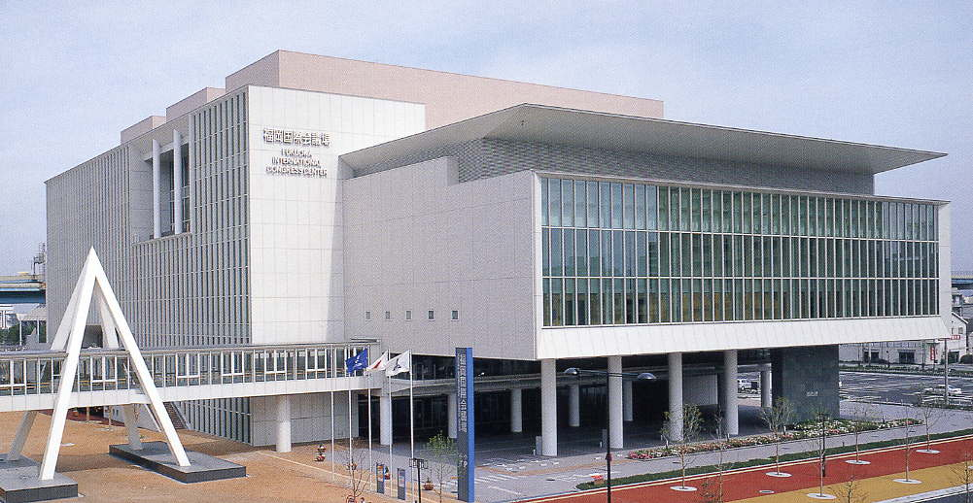
Conference Venue
Fukuoka International Congress Center
2-1 Sekijo-machi, Hakata-ku, Fukuoka 812-0032, Japan
Tel: +81-92-262-4111, Fax: +81-92-262-4701
URL: http://www.marinemesse.or.jp/congress/

Fukuoka International Congress Center is a modern five-story building, opened in March 2003, and the main venue of the 25th ITTC is the 5th floor of this building. The 1st floor (the ground floor in Europe) of the building is just the spacious entrance hall (and a restaurant, administration office, and so on). Once you enter from the front door, on the left-hand side of the entrance hall you will find an electronic display board, elevators (located behind the display board) and an escalator which will take you to the 5th floor, the main venue of the 25th ITTC.

Throughout the week starting from 14 September 2008, the 25th ITTC will occupy the majority of the 5th floor of Fukuoka international Congress Center. As summarized in Page 1 (Technical Programme), the registration will start at 14:00 on September 14 at the lobby of the 5th floor. The Conference sessions will start on Monday, September 15 in the morning after registration, with the welcome and opening, and will end on Saturday, September 20, with a closing ceremony after the plenary session.

All technical sessions and Group Discussions will be held in International Conference Room (No. 501, the biggest room on the 5th floor). The internet can be used in Room 506, where several numbers of LAN (Local Area Network) connectors are available free of charge. The wireless networking may not be available unfortunately. Thus if you are going to use the internet during the conference, you are advised to bring a LAN cable with you.

Coffee and tea will be served in the lobby of the 5th floor during the coffee break throughout the period of the Conference. Lunch will be served every day at Palace Room on the 2nd floor of Fukuoka Sunpalace Hotel (see Photo. The same room where the welcome reception is held). The 2nd floor of Fukuoka Sunpalace Hotel is linked to the 2nd floor of Fukuoka International Congress Center with an elevated connecting corridor. The floor layouts can be seen in the 25th ITTC website (http://riam.kyushu-u.ac.jp/ship/ittc/). Please check the relative locations of related facilities.
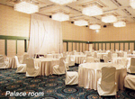
Accommodation

Hotel Nikko Fukuoka
2-18-25 Hakata Eki-mae, Hakata-ku, Fukuoka 812-0011, Japan
Tel: +81-92-482-1111, Fax: +81-92-482-1127
URL: http://www.hotelnikko-fukuoka.com/english/index.html

For your convenience, a number of rooms have been booked at Hotel Nikko Fukuoka as a main hotel for your accommodation with special rates for the 25th ITTC. For more details, please refer to the information on the 25th ITTC website (http://riam.kyushu-u.ac.jp/ship/ittc/).

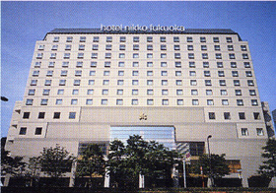
The Hotel Nikko Fukuoka is a superlative and world-class hotel located very conveniently just two blocks away from JR (Japan Railways) Hakata Station along Taihaku-dori Avenue. Located at the end of a straight line of Taihaku-dori Avenue are Fukuoka Sunpalace Hotel and Fukuoka International Congress Center, and the distance is about 1.8 km (about 25 minute walk). During the Conference, a complimentary bus will take you every morning (leaving about at 8:00) from the Hotel Nikko Fukuoka to the Conference Venue. Ordinary route buses are also available going directly to the bus stop nearest to the Conference Venue. There is a bus stop near the Hotel Nikko Fukuoka for taking these route buses. The information on the route bus is provided in the website of the 25th ITTC. The Hotel Nikko Fukuoka is the venue for the Conference Banquet of the 25th ITTC, scheduled on September 19.

To book a room at the Hotel Nikko Fukuoka, please go through the web page of “Accommodation” at the 25th ITTC website (http://riam.kyushu-u.ac.jp/ship/ittc/) and click “On-Line Reservation” banner, OR complete the Accommodation Booking Form on Page 19 and return it directly to Hotel Nikko Fukuoka by Fax: (+81-92-482-1127), no later than the end of July 2008. Accommodation Booking Form is also downloadable from the 25th ITTC website. Please be sure to check the reconfirmation mail or Fax after the completion of your reservation. Rooms will be allocated on 'first come, first served' basis. After the deadline, all reserved rooms with special rates will be released. Therefore, after the deadline (July 31st), you must put a reservation by yourself directly to the Hotel Nikko Fukuoka through the internet or other measures. For any changes and cancellation can be done through this On-line system or by a direct Fax to Hotel Nikko Fukuoka under your own responsibility.

Although there are many hotels in the downtown of Fukuoka City especially near and between Hakata and Tenjin areas, there are few hotels unfortunately around the Conference Venue.

For participants who wish to book rooms at other hotels, some information is provided through the 25th ITTC website, and also the same list of hotels and the map for locating the listed hotels are given on the last page of this brochure. The ITTC-2008 Secretariat provides only the information and will not be in charge of reservation and/or cancellation on these hotels. Please make a reservation on your own responsibility.

All rates quoted in the List of Other Hotels on the last page are for Bed & Breakfast as of April 2008. Participants should note that the hotels reserve the right to raise the rate or offer promotional rates on the internet or through travel agencies. Therefore participants are strongly advised to check directly with the hotels or through their travel agency for actual rates.

Proceedings
ITTC Member Organizations and invited participants to the Conference can download the Proceedings (Volume I and II) from the 25th ITTC website, once they are ready for download. (Please check from time to time on http://riam.kyushu-u.ac.jp/ship/ittc/.) Printed volumes of the Proceedings can be collected at the Conference. Those who have trouble in downloading the Proceedings should contact the 25th ITTC-2008 Secretariat so that printed volumes may be mailed to them.
Fukuoka
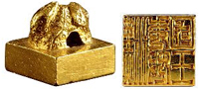
Fukuoka has the geometrical advantage of being closer to the Asian Continent than other places in Japan. With this advantage, Fukuoka has been serving as a gateway to import Asian culture from ancient times. The ancient Chinese scroll known as 'Record of the Later Han Dynasty' records how, in AD 57, the Emperor Gwang Wu gave a golden seal to an envoy from Japan. The golden seal (see Photo) found in Shikanoshima Island is a proof that there was exchange of continental cultures in the 1st century. During the 7th century till the 11th century, Korokan (an ancient guest-house) was the hub of cultural exchange. Later, in the 16th century, wealthy merchants from Hakata went overseas, seeking for profitable business. In 1889, the 22nd year of the Meiji Era, the City Administration Organization gave birth to Fukuoka City. In 1989, the Asian-Pacific Expo was held to celebrate the First Centennial of the Fukuoka City Administration at Momochi district.

Fukuoka is a city of marvelous historical sites, beautiful natural views with mild climate, colorful Japanese festivals known as “Yamakasa” and “Hakata Dontaku”, arts and crafts such as Hakata clay dolls and silk fabric. Fukuoka is the biggest city in Kyushu, with population of over 1.4 million people, occupying a central role in travel, information and entertainment, and is one of Japan's eight largest cities.

Central areas such as “JR Hakata Station”, through which most people travel between Kyushu and the rest of Japan, have the easiest and fastest access to the airport via the subway system. In Fukuoka's major commercial district “Tenjin”, department stores, underground shopping center, big-scale electric appliance shops are open seven days a week 10:00-20:00. Fukuoka City's unique charm is its blend of a big-city feel with beautiful natural spaces. It offers visitors a wild nightlife and endless shopping opportunities, a chance to visit traditional shrines and historical sights, and a unique cuisine.

Excellent access by air, land and sea
Fukuoka has excellent access and a highly functional urban environment. The entranceway to Fukuoka is, first of all, Fukuoka International Airport, which offers links to numerous cities in Japan, and 23 major cities overseas. Seoul is just 85 minutes away, and Shanghai can be reached in 100 minutes. Tokyo is a 90-minute flight, and Osaka 65 minutes. The biggest advantage of Fukuoka is that it takes only 10 minutes to reach the city center from the airport using the subway system.

By land, visitors reach Fukuoka by expressway or Japan Railways (usually written as JR) particularly Shinkansen, bullet trains you may say. Extension of the Shinkansen line into the south of Kyushu Island would be making travel more convenient and speedier.
Hakata Port, which is very close to Fukuoka International Congress Center, welcomes 2 million travelers a year. This port also serves as a terminal for the jet foil, which links Fukuoka to Busan, Korea, with a journey time of approximately 3 hours.

Transportation from Fukuoka Airport
Since Fukuoka Airport is very conveniently located as you can see on the map, it is easy to come to the center of Fukuoka City (i.e. JR Hakata Station or Tenjin) by using a subway or a taxi.
Note that the international and domestic flight terminals are separated (on the other side across the runway as shown on the map), and the shuttle bus between these two terminals is available every 10 minutes free of charge. Just outside the domestic-flight terminal No. 2 of Fukuoka Airport, you can easily find out the subway station; Fukuoka-kuko (Airport) Station.

When you fly into Fukuoka Airport by a domestic flight, subway will be the most reasonable and convenient transportation. With the subway system, Hakata Station is the second from Fukuoka Airport and it takes only 5 minutes. Furthermore, Tenjin Station is the third station from Hakata Station and it takes another 6 minutes. Buses are available from both Hakata and Tenjin Stations, the information of which is provided on the 25th ITTC website.

When you fly into Fukuoka Airport by an international flight, it might take a little more time. First, please take a free shuttle bus to domestic flight terminal and then take the subway. Another option is taking a taxi, which will be more convenient and can be recommended especially when you have large luggage. Although the journey time depends on the traffic condition, it takes normally about 15 – 20 minutes, and the taxi fare is about 1,500 – 2,000 Yen, depending on the distance and journey time.

Japanese taxi drivers are generally very kind and well-disciplined, but mostly they cannot understand English. It might be better for you to prepare a copy of a map downloaded from the website or a print-out with the name of your hotel and show it to them.
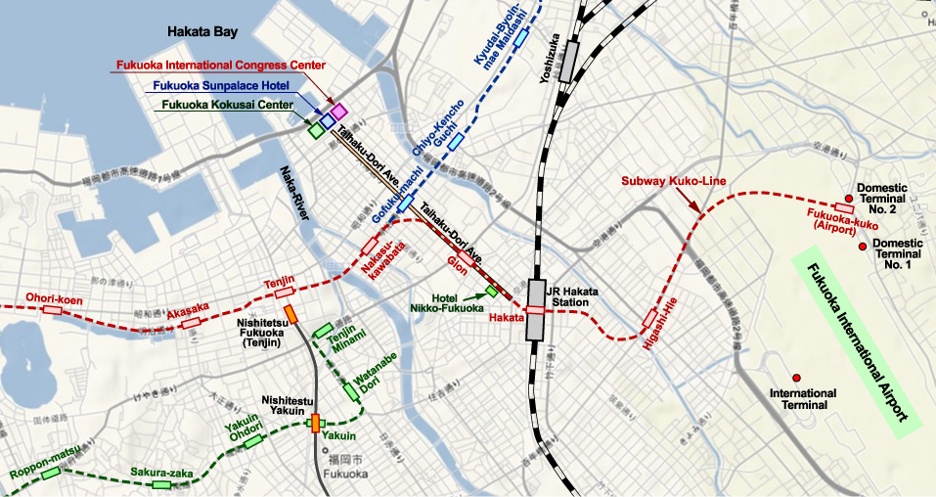
Climate and Clothing
The climate in Fukuoka is rather mild with the annual average temperature being around 17 °C. However, September is still a hot month in Fukuoka, and the average temperature is 28 °C with humidity 74%. Sometimes the lingering summer heat is so intense that the temperature at daytime can be over 30 °C and 25 °C in the evening. Once or twice in September, typhoon may hit or pass the western part of Japan and may disrupt transportation system for one or two days. Appropriate clothing for daytime is summer wear, long sleeve jacket or shirt for evening and air-conditioned rooms.

Currency
The unit of currency in Japan is Yen (indicated by \ or JPY). 100 JPY is equivalent to 0.98 US$ and 0.62 EUR, 1 US$ = 102.3 JPY and 1 EUR = 160.8 JPY as of April 15, 2008. The exchange rate is fluctuating especially these days and thus you had better check it just before your departure. Most foreign currencies can be exchanged at most local banks in the downtown area. International hotels, like Hotel Nikko Fukuoka and Hyatt hotels, can exchange US dollar and Euro into Japanese Yen and sometimes Korean Won. Traveler’s checks cannot be accepted at most shops so please cash the traveler’s checks at banks. Major credit cards are widely accepted, except at small souvenir shops or small self-supporting restaurants.

Please note that local banks close at 15:00 on weekdays and close on Saturdays and Sundays. Cash dispenser and cashing machines may be open until 17:30 everyday.

The most convenient and recommended place for money exchange is Fukuoka Airport. There are local bank offices and several cashing machines operated by credit card companies and Japan Postal Service. These banks provide better rate than hotels. Branch offices of local banks are open for business in the international-flight terminal and also in the basement of the domestic-flight terminal No. 2, where you may exchange major foreign currencies (like US dollar or EURO) into Japanese Yen.

Please also note that there are no cashing and exchange machines near Fukuoka International Congress Center, the venue of the 25th ITTC. The nearest cash dispenser and bank office exist at a distance of 15-20 minute walk from the Venue. We would like to recommend that you would exchange money right after arriving in Japan or Fukuoka Airport.

Passport and Visa
Visitors entering Japan from foreign countries must carry a valid passport and, in some cases, a visa is required. Participants are advised to contact their Japanese Embassy or local travel agent for details.

If you need our help or necessary documentations, please contact Ms. Mizuho Mizutani, Main Administration Supporter at ittc-2008@riam.kyushu-u.ac.jp.

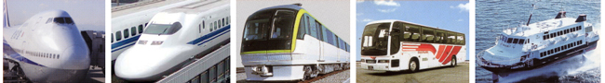
Local Transportation
The public transportation in Fukuoka City is very good with buses, subway, Nishitetsu Railway, JR Kyushu Railway, taxies and ships, taking you to anywhere in and near Fukuoka City. The bus centers located near JR Hakata Station and Nishitetsu Fukuoka (Tenjin) Station are hubs of the network, from where not only local but also long-distance buses depart frequently. Normally passengers are supposed to take a boarding ticket with reference number from the dispenser near the door when getting on, and the fare for that reference number to the current bus stop will be shown on the screen at the inside front of the bus. The fare indicated is supposed to be paid in cash when getting off. The easiest and cheapest bus is the so-called 100-Yen Loop Bus, getting round the city, stopping at principal places including Tenjin, Canal City, JR Hakata Station, Gofuku-machi Subway Station, Nakasu-Kawabata Subway Station, and so on. As the name implies, the fare is just 100 Yen, irrespective of the distance.

The subway system also offers convenient transportation, linking Fukuoka Airport with the center of Fukuoka City and further to the west-end of the City. Recently a new subway line, Nanakuma Line, was opened and thus there are three subway lines in Fukuoka City at present.

For more details for the transportation and sightseeing spots, please refer to the following links to relevant useful websites for your getting around Fukuoka City:

- Fukuoka City On Line
- Fukuoka Sights
- Fukuoka City Sightseeing Navigation Station
- Fukuoka City Subway
- JR Kyushu Railway Company
- How to Ride Nishitetsu Buses
- Page of Directions in the 25th ITTC website

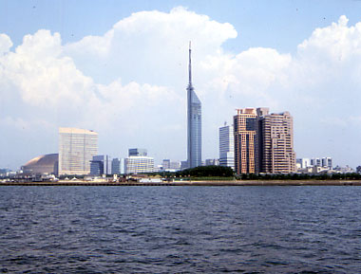
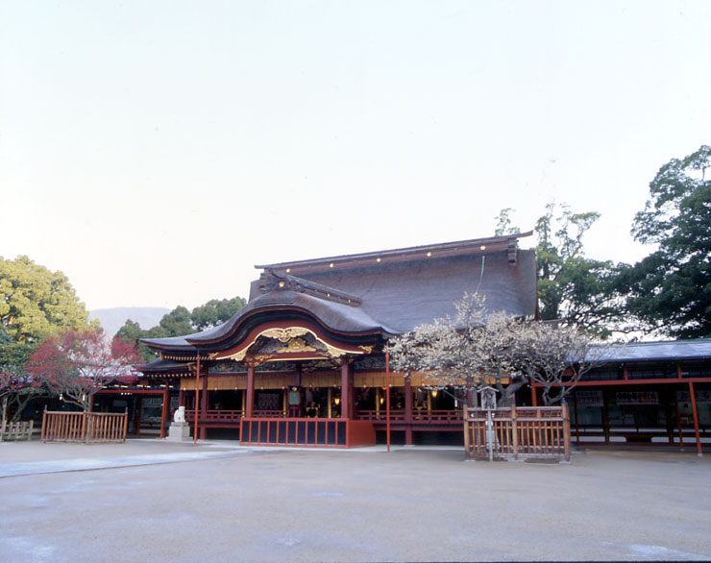
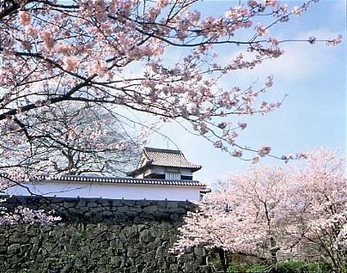
Dazaifu Tenmangu Fukuoka Castle Momochi District

For any inquiries, please contact
The 25th ITTC Secretariat
Section of Free-Surface / Interface Dynamics
Research Institute for Applied Mechanics, Kyushu University
6-1 Kasuga-koen, Kasuga, Fukuoka 816-8580, Japan
Fax: 81-92-592-4832
Main Administration Supporter: Ms. Mizuho Mizutani
E-mail: ittc-2008@riam.kyushu-u.ac.jp

Registration Information

Registration Fees
The registration fee (120,000 JPY) covers the conference proceedings, lunches and coffee breaks during the Conference, and social programme (Reception at Fukuoka Sunpalace Hotel, Conference Tour, and Banquet at Hotel Nikko Fukuoka). The registration fee for one accompanying person is 20,000 JPY, which covers all tour expenses for accompanying persons’ program, lunches during the Conference, and social programme.

Payment
All payments should be remitted in Japanese Yen. Payments can be made by credit cards through the 25th ITTC website or bank transfer.

Deadline for Registration
Please note that both the registration form and the payment must be received by the Registration Office no later than July 15, 2008 for the normal registration fee to be effective. The extra amount of 15,000 JPY will be applied for late registration (from July 16, 2008). The late registration must be completed by August 31, 2008.

Cancellation Policy
Refund of registration fees, subject to 12,000 JPY administration cost be subtracted, will be granted if written request is received by August 31, 2008. No refund will be made for cancellation after this date (unless due to causes of “force majeur”).

Further Information
Registration to the Conference will be acknowledged when the registration form and payment details have been received, of which ICS Convention Design, Inc. will be in charge, including any trouble associated with the registration.

Registration Form
The registration form for the Conference is given in the following pages. Participants should complete their form and send it to the 25th ITTC-2008 Registration Office (contact details given below). Alternatively, participants can register online at the 25th ITTC website.

ITTC-2008 Registration Office
c/o ICS Convention Design, Inc.
Sumitomo Corp. Jinbocho Bildg. 3-24, Kanda-Nishikicho
Chiyoda-ku, Tokyo 101-8449 Japan
TEL: +81-3-3219-3600 Fax: +81-3-3292-1811
E-mail: ittc2008-reg@ics-inc.co.jp

Inquiries and any contact will also be accepted at a special e-mail address of the 25th ITTC Secretariat: ittc-2008@riam.kyushu-u.ac.jp

Registration Form for the 25th ITTC
Please read carefully the Privacy Policy first.
ITTC-2008 Registration Office  c/o ICS Convention Design, Inc.  Sumitomo Corp. Jinbocho Bldg.  3-24, Kanda-Nishikicho  Chiyoda-ku, Tokyo 101-8449 Japan | Tel: +81-3-3219-3600  Fax: +81-3-3292-1811  E-mail: ittc2008-reg@ics-inc.co.jp  URL: http://riam.kyushu-u.ac.jp/ship/ittc/
Privacy Policy
ITTC-2008 – Privacy Policy

We (The Organizer) are committed to protect the personal information of the applicants.
Your personal identifiable information (personal information) will be collected via this form only when you make the registration and answer a questionnaire for this conference (here in after the "Conference").

Without an applicant's consent, we (the Organizer) will not use such information for the purposes other than operating and managing the Conference, responding to inquiries from applicants for the Conference and offering the Conference information to the applicants.

For smooth operation of the Conference, we (the Organizer) are entrusting the operations of collecting, storing, managing and handling personal information regarding the Conference to the following company who act as Registration Office under a confidentiality agreement.

In case there is an error in your personal information collected for the Conference, please inform the Registration Office to have it corrected or deleted.

Offering personal information is voluntary, but please note that you are unable to attend the Conference without offering the necessary information.

Contact Information of the Registration Office managing personal information
ICS Convention Design, Inc.
Kyushu Office
Attn: Kazuhiro Yonekura
Shin KBC Building 9F, 1-1-35 Nagahama, Chuo-ku, Fukuoka 810-0072 Japan
Phone: +81-92-751-3244
Fax: +81-92-751-3250

Administrator of personal information collected for the Conference
Attn: Katsuro Kijima
Chairman of the Organizing Committee of ITTC 2008
Professor Emeritus of Kyushu University
2-12-9 Shiba-daimon, Minato-ku, Tokyo 105-0012
The Japan Society of Naval Architects and Ocean Engineers
Phone: +81-3-3438-2014
Fax: +81-3-3438-2016

Please complete this form and return it by fax.
Privacy Policy
I have read and agreed to the privacy policy.

Signature Date
Participant
Family Name: |  |  | Given Name:
Title (please circle): Mr. Ms. Dr. Prof. |  |  | Position:
Affiliation:
Mailing Address (please circle): Home Office
Address:

Country:
Phone: |  |  | Fax:
E-mail:
Meal Request for the Banquet (See Page 4)
We can offer three kinds of menu for the Banquet. Please check one appropriate box.
Standard Menu Standard Menu (something-free main dish) Vegetarian Menu

Conference Tour
Please check one appropriate box Tour A or Tour B (For details, please refer to Page 3)
Tour A: National Museum & Dazaifu Shrine |  | Tour B: Toyota Factory Tour & Old Residence
Accompanying persons: Family Member(s) Only
Accompanying person 1 | If under 18, please specify age. ( )
Family Name: |  |  | Given Name:
E-mail or fax number for later contact from the Secretariat:
Conference Tour: A B, Banquet Menu: Standard Standard (something-free) Vegetarian
Accompanying person 2 | If under 18, please specify age. ( )
Family Name: |  |  | Given Name:
Conference Tour: A B, Banquet Menu: Standard Standard (something-free) Vegetarian
Accompanying person 3 | If under 18, please specify age. ( )
Family Name: |  |  | Given Name:
Conference Tour: A B, Banquet Menu: Standard Standard (something-free) Vegetarian
Meal Requests for You and Accompanying person(s).
If you have any dietary restrictions due to health or religious reason, please specify them. We will consider the information for the selection of Banquet and lunch menu.
Please fill out the appropriate boxes
Conference Fees |  |  | Unit Price (Yen) | Number | Total (Yen)
Registration Fee until July 15, 2008 |  |  | 120,000
Registration Fee from July 16, 2008 |  |  | 135,000
Accompanying Person’s Fee |  |  | 20,000
Total JPY
- The registration fee covers the conference proceedings, lunches and coffee breaks during the Conference, and social program (Reception at Fukuoka Sunpalace Hotel, Conference Tour, and Banquet at Hotel Nikko Fukuoka).
- The accompanying person’s fee covers all the expenses for accompanying persons’ program and social program.
Please check appropriate boxes and complete this part of the form
Group Discussions
I wish to take part in the following Group Discussions:
GD-1 Impact of CFD on Ship Hydrodynamics (September 16, Tuesday)
GD-2 Image-based Measurements around Ship Hulls (September 17, Wednesday)
GD-3 Global Warming and Impact on ITTC Activities (September 19, Friday)
Please indicate the method of payment
Bank Transfer
I (We) have remitted or will remit the above sum of JPY (total) on (date)
by the name of (remitter) through (name of bank) to:
Banking Information
Name of Bank: The Bank of Tokyo-Mitsubishi UFJ Ltd.
Address of Bank: 1-1-1 Otemachi, Chiyoda-ku, Tokyo, 100-8114
Account Number: (Ordinary Account ) 4934936
Account Name: ITTC2008
*Bank, currency and transfer charges are the responsibility of the payee.
Please ensure that the organizer is paid the full conference fee.
Credit card
Please note that for security reasons it is advised to send this form with credit card details by fax.
Credit card details
Card Type: | Visa | Master |  | Diners Club | AMEX | JCB
Card Number: |  |  |  | Expire Date:
Card Holder’s Name:
Date: |  |  | Signature:
Please send the completed registration form to the ITTC-2008 Registration Office.
ITTC-2008 Registration Office  c/o ICS Convention Design, Inc.  Sumitomo Corp. Jinbocho Bldg.  3-24, Kanda-Nishikicho  Chiyoda-ku, Tokyo 101-8449 Japan |  |  |  | Tel: +81-3-3219-3600  Fax: +81-3-3292-1811  E-mail: ittc2008-reg@ics-inc.co.jp  URL: http://riam.kyushu-u.ac.jp/ship/ittc/


Hotel Nikko Fukuoka Accommodation Booking Form
The 25th International Towing Tank Conference (ITTC)
14th – 20th September 2008

Guest Name:
Telephone Number:
Fax Number:
E-mail Address:
Arrival Date:
Departure Date:
Number of Nights Required:
Number of Adults:
Type of Room Requested*:  Smoking or Non-smoking Room | (Please circle) Single Twin Double  Smoking room Non-smoking room
Credit Card Information
Kind of Card, Card Number:
Name on Card, Expiration Date:

Rates: | 15,000 Yen Bed & Breakfast per single room occupancy per night
 | 20,000 Yen Bed & Breakfast per double/twin room for single occupancy per night
 | 24,000 Yen Bed & Breakfast per twin/double room for double occupancy per night
All rates include the tax and service charges.
* Please note that double-bed rooms (the number of which is just 20) will be allocated with priority to single occupancy. For other information, please see the website of the 25th ITTC (http://riam.kyushu-u.ac.jp/ship/ittc/) .

Please note, any cancellation or amendments to individual reservations must be notified to the Hotel Nikko Fukuoka at least 7 days prior to the arrival date or a 100% cancellation charge will be applicable.
In addition, full payment for bed and breakfast and all extras is required on departure from the hotel.

Please go through the web page of “Accommodation” at http://riam.kyushu-u.ac.jp/ship/ittc/
and click “On-Line Reservation” banner,
OR complete this booking form and send directly to the Hotel Nikko Fukuoka
by Fax (+81-92-482-1127) no later than Thursday 31 July 2008.

The hotel contact details are as follows:
Hotel Nikko Fukuoka, 2-18-25 Hakata-ekimae, Hakata-ku, Fukuoka 812-0011, Japan
Tel: +81-92-482-1111, Fax: +81-92-482-1127, E-mail: goodstay-rsv@hnf.co.jp
URL: http://www.hotelnikko-fukuoka.com/english/index.html
List of Other Hotels for Your Reservation

The list of hotels (except for Hotel Nikko Fukuoka) in the downtown of Fukuoka City is given below and the serial number of the hotels corresponds to the location in the map on the next page. All rates quoted in this list are rack rates announced to the public through hotel’s web pages as of April 2008. Participants should note that the hotels reserve the right to raise the rate or offer promotional rates on the internet or through travel agencies. Therefore participants are strongly advised to check directly with the hotels or through their travel agency for actual rates.

No | Name of Hotel |  | Room Type |  |  | Tax
No |  |  | Single | Twin | Japanese style *** | Tax
1 | Grand Hyatt Fukuoka |  | 28,000 | 37,000 | 76,000 | *
2 | Hotel Okura Fukuoka |  | 19,950 | 29,400 | 68,250 | **
3 | Hyatt Regency Fukuoka |  | 19,635 | 28,875 | – | *
4 | Hotel New Otani Hakata |  | 18,900 | 30,450 | 52,500 | **
5 | ANA Hotel Hakata |  | 15,592 | 24,486 | – | *
6 | Hotel Monterey Le Soeur Fukuoka |  | 13,860 | 25,410 | – | *
7 | Nishitetsu Grand Hotel |  | 12,705 | 25,410 | 30,030 | *
8 | Hakata EXCEL Hotel Tokyu |  | 12,705 | 20,790 | – | *
9 | Hakata Miyako Hotel |  | 12,474 | 21,945 | 25,410 | *
10 | Hotel Sunroute Hakata |  | 10,080 | 20,370 | – | **
11 | Canal City Fukuoka Washington Hotel |  | 9,200 | 17,500 | – | *
12 | APA Hotel (Fukuoka-Watanabe Dori) |  | 8,000 | 16,000 | 20,000 | *
13 | Central Hotel Fukuoka |  | 7,800 | 13,300 | – | *
14 | Reisenkaku Hotel (Kawabata) |  | 7,035 | 11,340 | – | *
15 | APA Hotel (Hakata-Ekimae) |  | 7,000 | – | – | *
16 | Toyo Hotel |  | 6,825 | 12,285 | – | *
17 | Reisenkaku Hotel (Ekimae) |  | 6,720 | 10,290 | – | *
18 | Toyoko Inn Club (Hakata-guchi) |  | 6,400 | 8,400 | – | *
19 | Comfort Hotel Hakata |  | 6,000 | 12,000 | 14,000 | **
20 | Toyoko Inn (Hakata-guchi Ekimae) |  | 5,880 | 8,610 | – | **
21 | Hakata Terminal Hotel |  | 5,800 | – | – | *
22 | Toyoko Inn (Hakata Gion) |  | 5,460 | 8,400 | – | **
23 | Hakata River Side Hotel |  | 4,500 | 8,000 | 8,000 | **
Rates are in Japanese Yen
* |  | Tax and service charge included
** |  | Tax included, no service fee is charged
*** |  | Two guests per room

Map for Locating the Hotels in the List
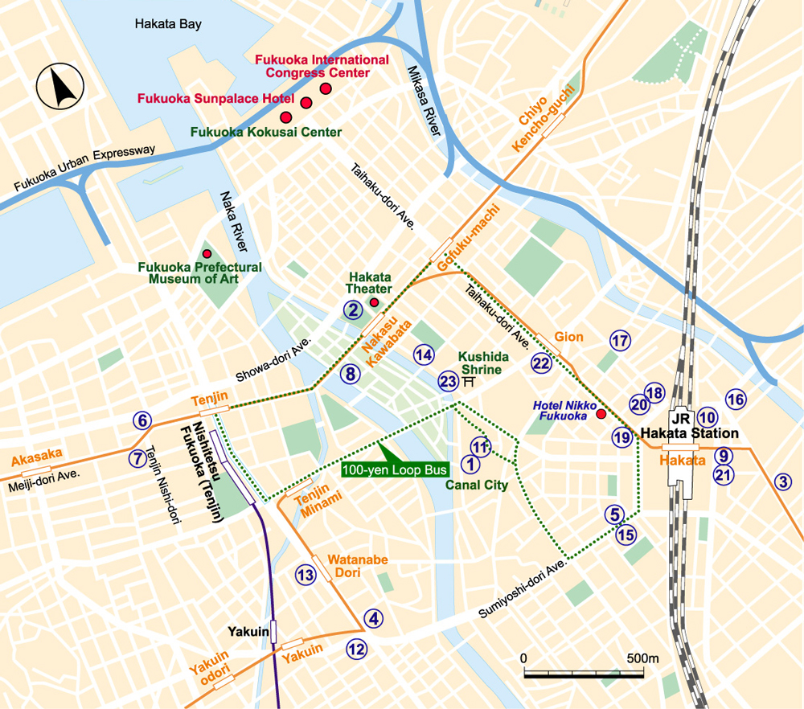

The ITTC-2008 Secretariat provides only the information and will not be in charge of reservation and/or cancellation on these hotels. Please make a reservation on your own responsibility.

The 25th ITTC Secretariat
Section of Free-Surface / Interface Dynamics
Research Institute for Applied Mechanics, Kyushu University
6-1 Kasuga-koen, Kasuga, Fukuoka 816-8580, Japan
Fax: 81-92-592-4832
Main Administration Supporter: Ms. Mizuho Mizutani
E-mail: ittc-2008@riam.kyushu-u.ac.jp

